Westside FCCLA
1002 Patriot’s Way
706-868-4030
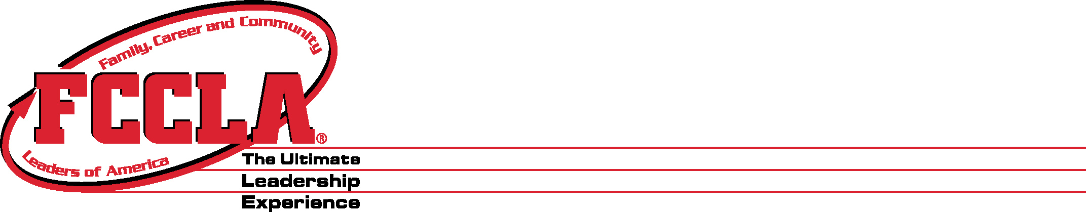

Dear Parents,

Your child has the opportunity to join a national student organization by enrolling or having already completed at least one class within the Human Services (Family & Consumers Sciences) Pathway. The student organization is Family, Career and Community Leaders of America (FCCLA). FCCLA is a student led organization with the family as the central focus. The skills focused on encourages students to develop leadership skills in many various areas that will benefit them throughout their school career. We will have meetings monthly; which all members are encouraged to attend. In February, we will celebrate national FCCLA week and host member activity events yearlong. We also have days for service learning projects around the school and the community. Throughout the school year, we attend local & state level events. Region, State, & National events are included in the chart below. Our local events, such as community service projects around Augusta will be determined later. Community Service Projects and Local Events are based on the need at that time, within the community. Please understand all events are optional for members to attend.

Date/Event/Location | Registration/Requirements | Deadline to register | Who is invited
Sept. 14, 2023  FCCLA Discovery Training  Fort Valley, Ga | $25 (early) or $30 (regular)  - Health Insurance Card  - Field Trip Permission Packet | Aug. 29, 2023  Early Registration  Aug. 31, 2023  Regular Registration | Any one wanting to learn more about leadership
Oct. 11, 2023  Fall Leadership Rally  Perry, Ga | $30 (early) or $40 (regular) or $50 (late)  - Health Insurance Card*  - Field Trip Permission Packet  **for fair armbands add $20**  *if it has not already been submitted previously | Sept. 7, 2023  Early Registration  Sept. 12, 2023  Regular Registration | Paid Members
Nov. 14-15, 2023  Fall Leadership Conference  Georgia FFA-FCCLA Center (Covington, Ga) | $80 (early) or $90 (regular)  - Face to face parent meeting  - Health Insurance Card  - Field Trip Permission Packet | Oct. 12, 2023  Early Registration  Oct. 16, 2023  Late Registration | Paid Members
Dec. 9 or 16, 2022  Region Meeting  Augusta, Ga | $15  - Registration | TBA | Paid Members
Feb. 10, 2024  Region STAR Events  Augusta, GA | $20 (early) or $30 (regular) or $40 (late)  - Registration | Dec. 15, 2023  Early Registration  Jan. 17, 2024  Regular Registration | STAR Events competitors
March 17-19, 2024  State Leadership  Athens, GA | $150-$165 (approximately)  - Face to face parent meeting***  - Health Insurance Card**  - Field Trip Permission Packet* | Feb. 13, 2024  Early Registration  Feb. 15, 2024  Regular Registration | STAR Events competitors
June 29 – July 3, 2024  National Leadership Conference  Seattle, WA | TBD  - Face to face parent meeting***  - Health Insurance Card**  - Field Trip Permission Packet* | TBA | 1st & 2nd Place Gold Competitors from State Leadership

The fee for joining FCCLA is only $15, which includes local, state, and national dues. A $30 membership includes a WHS FCCLA t-shirt along with local, state, and national dues. If you have any questions or concerns, please contact an adviser (Ms. Gibson or Ms. Stone) here at Westside (706) 868-4030.

